CRAIG ANDERSON
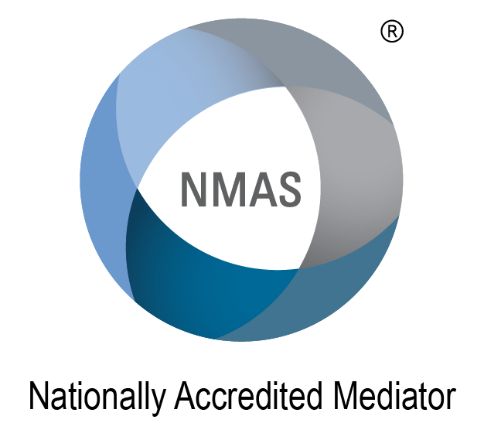
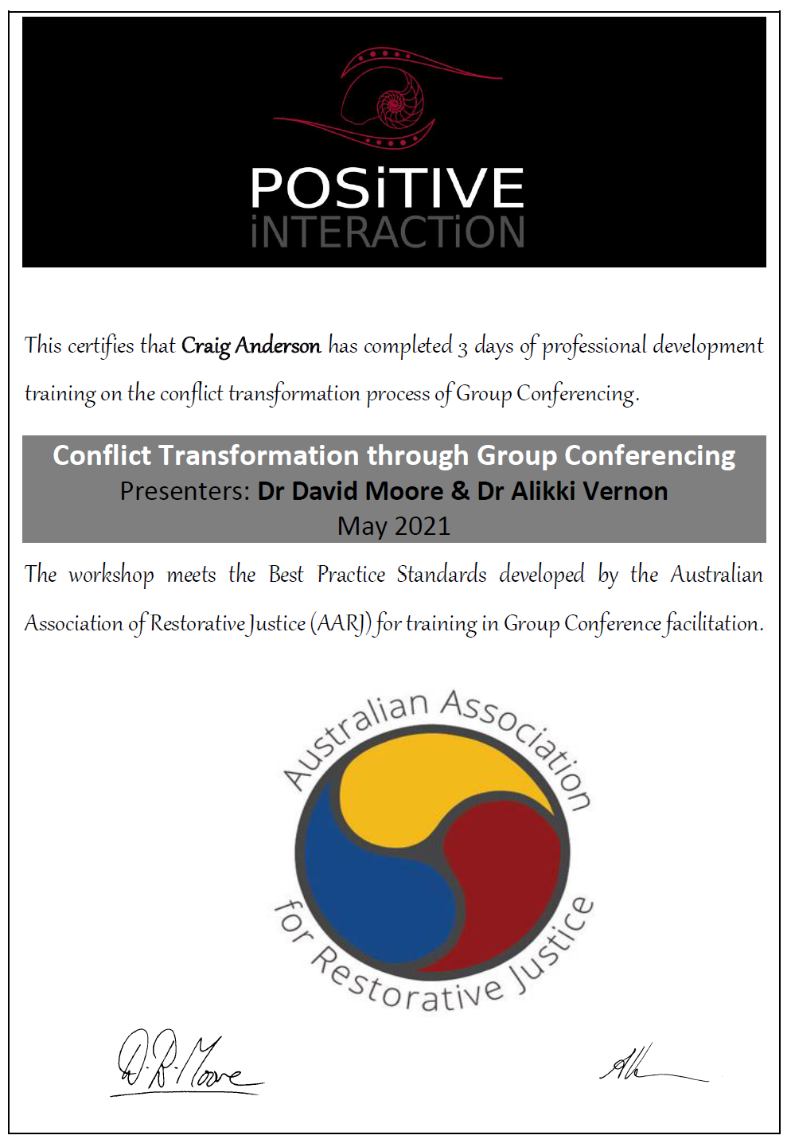
Mediate-Me Dispute Resolution Services
Profile  Hi I am Craig Anderson. I have a lifetime of experience beginning in Electrical Engineering, transitioning early to church leadership at local state and national level. I have been an active Police Chaplain since 2005. Now trained as a mediator (NMAS) and also trained as a Redress and Conflict conference facilitator.  CONTACT  Phone: 0412 118750  Websites:  www.mediate-me.com  www.mediationinstitute.edu.au  www.mediationawarenessweek.org.au  Email:  craig@mediate-me.com  Available for  - Mediation – workplace, neighbor, elder, business, will, finance and property.  - Redress Facilitator. – Assisting organisations who are engaged in the offer of redress for survivors of abuse, planning and conducting a group conference with the participants.  - Group Conferencing – Conflict resolution through group conferencing in Schools, Workplaces, Community Groups. |  | Qualifications and Accreditations  - Bach Eng. (Elec.)  - M. Min. Lead  - Accredited NMAS Mediator  - Conflict Transformation through Group Conferencing.  - Cert IV in Workplace Assessment & Training TAE 40110  WORK EXPERIENCE  Contract & Independent Mediator – Emverio Workplace Solutions and Interact Online 2019 - Present  Workplace and general dispute resolution services available face to face and online.  Pastor Christian Outreach Centre/International Network of Churches  1980 – Present  Youth Pastor; Regional Pastor (Brisbane); Executive Pastor (3000 member Church); Church Planter (Melb); State Director Victoria; Member of National Executive. Much of my 40 years’ experience in leadership at a National, State and Local level has been working with people in conflict resolution.  S.E.Q.E.B. First Year Engineer  1980  Forward planning for High Voltage distribution in South East QLD.  Volunteer Roles  VICTORIA POLICE CHAPLAIN  2005-Present – Serving North Western Region – Whittlesea Police Area  WHITE RIBBON AMBASSADOR  2012-2019  Community involvement working at prevention of Family Violence.  DESTINY RESCUE  2005-2015  Board Member of NFP Charity rescuing children from Sexual Exploitation in 6 nations  REFERENCES  Snr Sgt Paul Mellick – Epping Police  Ms. Suellen Holmes. – Sec. INC National Executive.  Ms. Anna Faoagali – Director of Emverio Workplace Solutions.  Ms. Joanne Law – Director of Interact Online Mediation Services.
Contact me for more information about the mediation and other services I provide. By appointment in Melbourne or Via Video Meeting

