PRE-MEDIATION PROCESS
MEDIATION CAN BE ACCOMPLISHED FACE TO FACE OR VIA VIDEO CONFERENCING.
Step 1 – Preparation and environment
Arrange for the Mediator to meet with each party either face to face or via video conferencing. I can provide meeting rooms at low cost to clients. Meeting times can be during the day or in the evenings or weekends.
Step 2 – Introductions
- The mediator Introduces himself.
- The mediator asks the party to introduce themselves and confirm how they would like to be addressed.

Step 3 - Opening Remarks by Mediator
- Confirm that party is there voluntarily and willing to resolve the issues.
- Let them know that any party to the mediation can terminate it at any time for any reason.
- Our purpose here today – The session is to inform them about mediation, make sure that mediation is appropriate and help them to prepare for the mediation session.
- Confidentiality – inform them that the discussion is confidential and nothing will be shared with the other parties unless duty of care obligations are activated.
- What is mediation? Mediation is a process that promotes the self-determination of participants and in which participants, with the support of a mediator:
(a) communicate with each other, exchange information and seek understanding
(b) identify, clarify and explore interests, issues and underlying needs
(c) consider their alternatives
(d) generate and evaluate options
(e) negotiate with each other; and
(f) reach and make their own decisions.
- Future Focus – the purpose of mediation is to find a way to resolve the issues that have brought you to mediation and the focus is on the future.

Step 4 – Explain the Agreement to Mediate
- Mediators Role – is to be a neutral facilitator and won’t give advice or specific suggestions. He will help the parties to communicate and negotiate. He will explain how he will document their agreement.
- Parties Role – to negotiate collaboratively and in good faith. That means to be open and honest about your needs and interests and consider then needs of the other party and be willing to identify a compromise that will allow resolution or ideally a win/win solution that works well for both.
- Confidentiality Mediators – anything you say in pre-mediation or on the mediation proper is confidential unless I have an obligation to report a disclosure to appropriate authorities such as a threat of harm or damage to property.
  - The mediator will clarify any specific exclusions e.g information requests from workplace or others.
- Confidentiality / Inadmissibility Parties - Mediation is confidential and new information volunteered during mediation can’t be used in other situations such as legal actions. The mediator will confirm if there is anyone that the party needs to speak with e.g significant other, adviser and that they will be asked to respect the confidentiality of the issue.
- Explain the Mediation process –
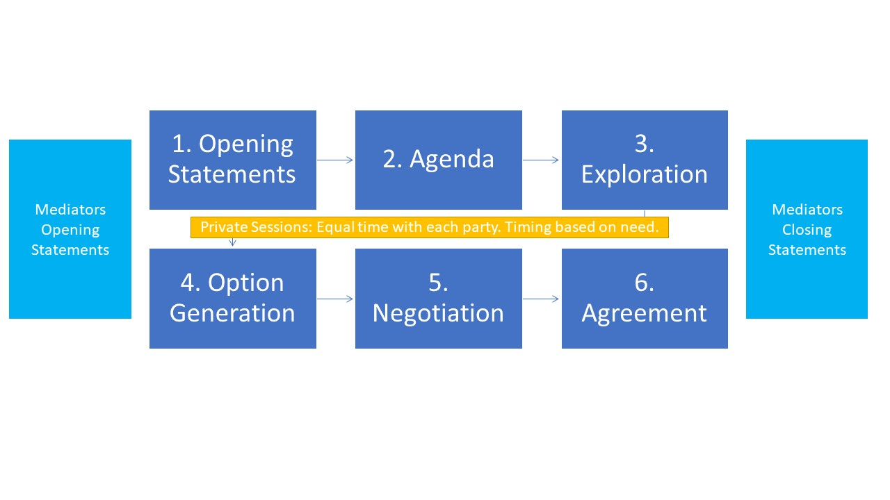

- Legal Status of the Agreement – any agreement reached is generally non-binding “moral agreement” and further steps would be required to make it legally enforceable. Signed and dated agreements may be regarded as contracts and are not confidential or inadmissible unless the agreement states that it is.

Step 5 – Ask party about their dispute
- Using Intake form the mediator will ask the party about their dispute, history and risk of violence, current legal processes and any other relevant information
- Find out position, needs and interests
- Discuss the need for additional legal or financial advice

Step 6 – Determine if mediation is appropriate
- Discuss any concerns about proceeding to mediation with the party
- Assist with determining how to prepare for the mediation session with the other party
- Determine how to proceed

Step 7 – Discuss Ground Rules for the mediation
- Ground Rules – are used to ensure that your Mediation is a respectful and constructive process.
- Let each other speak without interruptions – use the paper you have to jot down notes if you’re worried that you’ll forget something
- Really listen to what the other person is saying – that means not just what they say but what they mean, asking questions to clarify at the appropriate time if you need to.
- Be respectful – for me that mean no swearing or sniping at each other and no non-verbal nasties. Act the way you would as if this was a business meeting with an important client.
- Check in that the party agrees to the terms

Step 8 – Give additional resources, referral information
- Give party any additional information to take away with them
- Find out potential times / dates for next session (or confirm if the party is the 2nd person to attend)
- Agree on contact methods

Working with you for a better outcome,
Craig Anderson
Owner Mediate-Me,
NMAS Nationally Accredited Mediator.
Bach. Elec. Eng. M. Min.Lead.

