What does NMAS Mean?

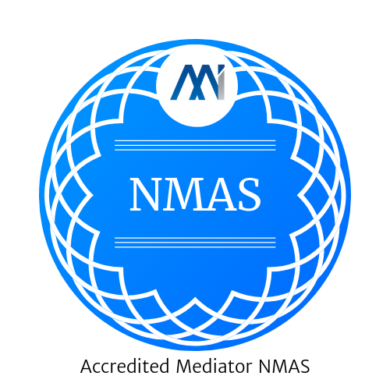
NMAS is an acronym for National Mediator Accreditation System.
It is a voluntary industry standard for mediators to show that they have been trained, assessed for competence, have demonstrated that they are of good character and have insurance.
To maintain their NMAS Accreditation they need to participate in continuing professional development and be doing mediation work.
Using a mediator who is not NMAS Accredited risks getting someone who does not uphold the ethical standards and who may not even be trained in mediation.
Our recommendation is don’t work with someone who says they are a mediator but has not bothered to become NMAS Accredited.

How can I tell if a Mediator is NMAS Accredited?
There is a public register of NMAS Accredited Mediators. If they are not on the register they are not a current Accredited Mediator through NMAS.
Check the Register for your Mediator

What does “Accredited By” mean on the register?
The NMAS System is administered by the Mediators Standards board, but they have delegated authority for the actual accreditation process to Recognised Mediator Accreditation Bodies (RMAB’s) such as Mediation Institute.
The RMAB checks eligibility for the mediators accreditation and renewals every two years. They are also often, but not always, the independent complaint handling service for the mediator.
Get a copy of the NMAS here

What is an independent complaint handling service?
The NMAS System in addition to providing guidance for how mediators need to be trained and assessed provides the industry with a set of practice standards which make sure that mediators work in a legal and ethical way upholding the principles of mediation in their work.
If a client has an issue with a mediator that isn’t able to be resolved they can escalate their complaint to the mediators independent complaint handling service. The information about how to make a complaint should be freely available to all NMAS Accredited mediator’s clients, usually in their agreement to mediate.
Find out more about complaining about a Mediation Institute Member.

Yours Sincerely,
Craig Anderson
Owner Mediate-Me,
NMAS Nationally Accredited Mediator.
Bach. Elec. Eng. M. Min.Lead.

